Face Recognition Attendance System
1. Introduction
The Face Recognition Attendance System is a smart application that automatically records attendance using face recognition technology. Instead of marking attendance manually, the system detects a person’s face through a webcam and identifies the person using stored images. After recognizing the face, the system records the person's name, date, time, and status (Entry or Exit) in an Excel file. This system helps reduce manual work and improves accuracy in attendance management.

2. Objective
The main objectives of this project are:
- To automate the attendance marking process.
- To use face recognition technology for identifying students.
- To reduce manual errors in attendance recording.
- To store attendance data automatically in an Excel sheet.
- To make the attendance process fast and efficient.

3. Tools and Technologies Used
Programming Language
- Python
Framework
- Streamlit
Libraries Used
- OpenCV – Used for capturing images from the webcam.
- face_recognition – Used to detect and recognize faces.
- NumPy – Used for numerical operations.
- Pandas – Used to store attendance data in Excel format.
- Datetime – Used to record date and time.
- OS – Used to access files and folders.

4. System Working
The working of the Face Recognition Attendance System is as follows:
- Student images are stored in a folder named students.
- The system reads all the images and converts them into face encodings.
- When the user starts the camera, the webcam captures live video.
- The system detects faces from the video frame.
- The detected face is compared with stored images.
- If a match is found, the student's name is identified.
- The system records the attendance with Name, Date, Time, and Status (Entry or Exit).
- A motivational quote is displayed to make the application user-friendly.
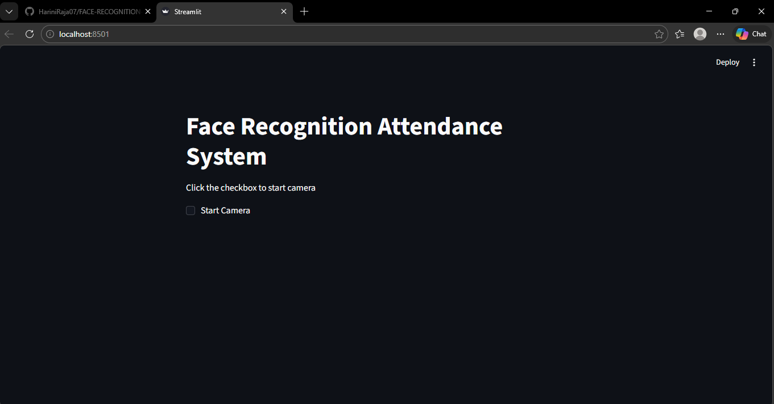
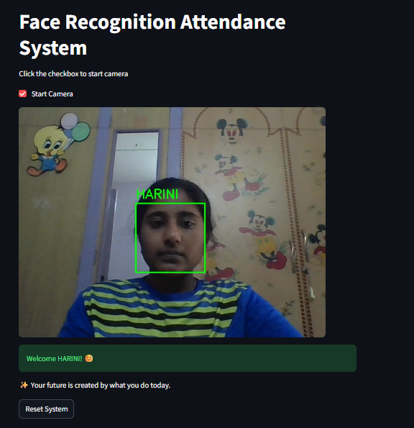
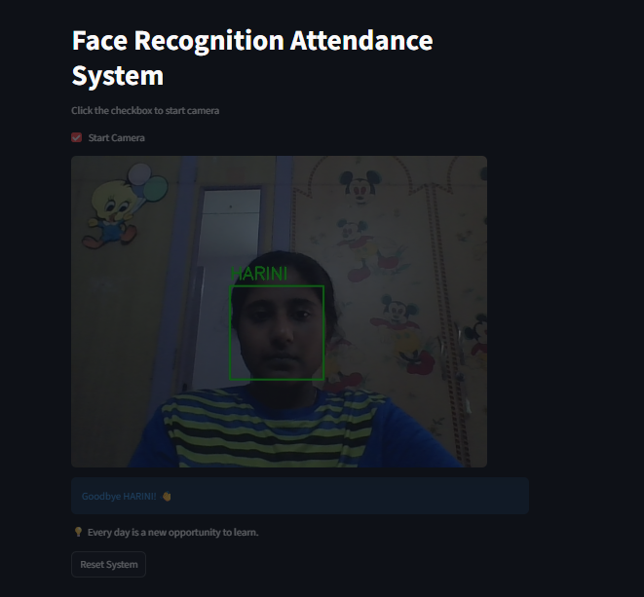
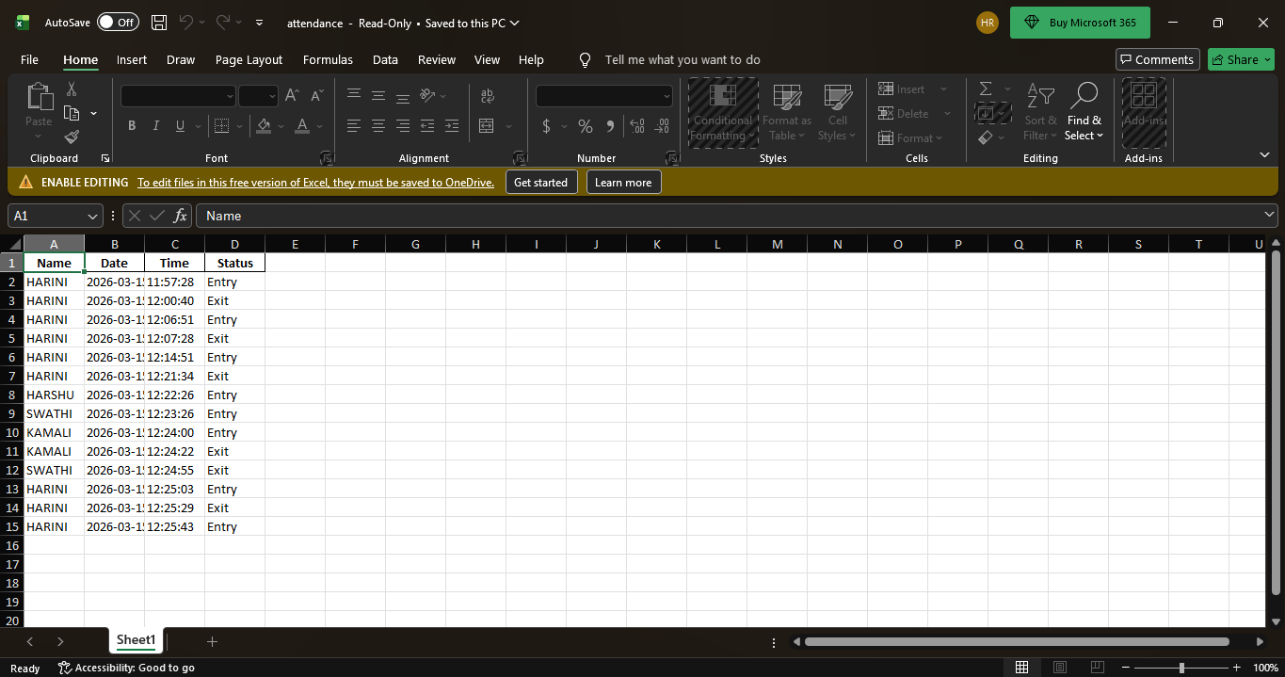

5. Features of the System
- Automatic face recognition.
- Real-time webcam detection.
- Entry and Exit tracking system.
- Attendance stored in an Excel file.
- Motivational quotes for users.
- Reset button to restart the system for the next user.

6. Advantages
- Saves time compared to manual attendance.
- Reduces human errors.
- Provides contactless attendance system.
- Easy to use and user-friendly interface.
- Can be used in schools, colleges, and offices.

7. Conclusion
The Face Recognition Attendance System is a useful application that uses artificial intelligence and computer vision to automate attendance management. This project shows how technology can improve efficiency and accuracy in daily tasks. By using face recognition, attendance can be recorded quickly and securely without manual effort.

8. Future Enhancements
- Integration with a database instead of Excel.
- Support for multiple cameras.
- Mobile application support.
- Cloud storage for attendance data.
- Email notification for attendance reports.

